Grupos projeto - Deep Learning

Grupo 1 -

Grupo 2 -

Grupo 3 -

Grupo 4 -

TEMAS

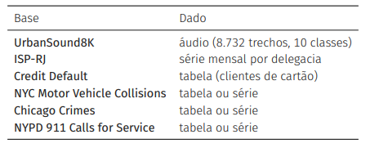

Dataset/Topico | Notebook
MNIST 1 | https://colab.research.google.com/github/fchollet/deep-learning-with-python-notebooks/blob/master/chapter02_mathematical-building-blocks.ipynb
MNIST 2 | https://keras.io/examples/vision/mnist_convnet
IMDB 1 | https://colab.research.google.com/github/fchollet/deep-learning-with-python-notebooks/blob/master/chapter04_classification-and-regression.ipynb
IMDB 2 | https://keras.io/examples/nlp/text_classification_from_scratch
Cats vs Dogs | https://keras.io/examples/vision/image_classification_from_scratch
Transfer Learning | https://keras.io/guides/transfer_learning
Jena Climate | https://colab.research.google.com/github/fchollet/deep-learning-with-python-notebooks/blob/master/chapter13_timeseries-forecasting.ipynb

